Submitting school health data reports for the 2022-2023 school year
Including SBIRT data reports, BMI data reports, Epinephrine Administration reports, and data reports for CSHS-funded schools (Monthly Activities report, Status report)

How has the data reporting process changed this year?
DPH is using a new online data reporting platform this year and the process for submitting data has changed slightly. Please read these instructions so that you can become familiar with the new process.
How do I edit a partially completed report, or a previously submitted report?
The most significant change is the procedure for editing an existing data report. In the past, you could simply click on the link to the online report, and as long as you were using the same computer you used to submit the original report, you could pull up your previous data submission, edit it, and re-submit. That no longer works. This year, you can still edit a previously submitted report, but to pull up a prior data report and edit it, you will need the report-specific link (and not just the regular link that opens a blank copy of the form). To get the report-specific link, click the Save and Return Later button to make sure your data is saved. You will then see instructions on screen for sending the report-specific link to your email address. You can also obtain the report-specific link (also known as the as the Survey Link) by bookmarking the page that has your partially completed, saved data. It might be useful to re-name the bookmark, so it includes the type of report and the date (For example: “Monthly Report: Sept 2022” or “School Health report-SY2023”). Whenever you need to edit that report, simply open the bookmarked page.
If you need to edit your report later but do not have the report-specific link and have not bookmarked the page that has your saved data, then you will not be able to edit your report and you will need to re-submit the report and re-enter all of your data. When we receive a duplicate report, we save only the more recently submitted report and discard any earlier reports.
What if I need to return to a prior page of my report to view or edit it?
For the BMI, SBIRT, or CSHS Status Report: Do not click the Back button on your browser. Instead, click the Survey Queue button located in the upper right-hand corner of the screen. Another screen will pop up showing the different survey sections. To edit your response, just find the section of the report you want to edit and click the corresponding Edit response button. Then you can edit the report and re-submit it. This does not apply to any of the other data reports. For the Epinephrine Administration report, click the “Previous Page” button. For all other reports, there is only one page, so to edit a previous section, simply scroll up the page.
How do I save a copy of my report?
Please save a copy of all of the reports you submit. We will not be able to retrieve your report and send it to you. You may be able to download a pdf file after you click Submit, but that copy may not be complete or readable. To save a better copy, before you click Submit, print the page to a pdf file or print a hard copy of the page (right-click on the page and select Print). For a multi-page report, print each page separately.

How do I know my report was submitted successfully?
When you have successfully submitted a report. you will see a "Thank you" message on screen after you click Submit. The “Thank you” message does not appear after you click Save and Return Later. You will not automatically receive an email confirmation.

Entering SBIRT data before other school health data
Can I submit my SBIRT data early in the school year, and wait until the end of the school year to submit BMI (or other) data?
You can do that if you use the following procedure.
- To begin entering SBIRT data, click the link to open up the online form. Enter your identifying information, and for question 11, select “Only SBIRT data”.
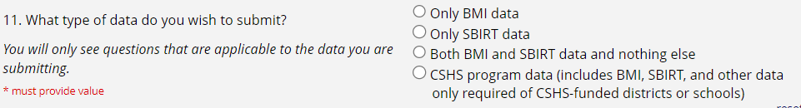
- When you click Submit, you will be taken directly to the SBIRT data page. Enter your SBIRT data and then click Save and Return Later and, when prompted, have the direct Survey Link sent to your email address. Bookmark the page as well.
- Later in the year, when you are ready to enter other data (such as BMI data), do not click the original link to the form, but instead open up the page you bookmarked in Step 1 (or use the direct Survey Link if you had it sent to your email address).
- Once you have opened the page you bookmarked earlier, go to the upper right-hand corner of the screen, and click the Survey Queue button.
- You should see the applicable sections of the report listed. Click the “Edit response” button next to “Section 1. School and District Information” to open that section for editing.
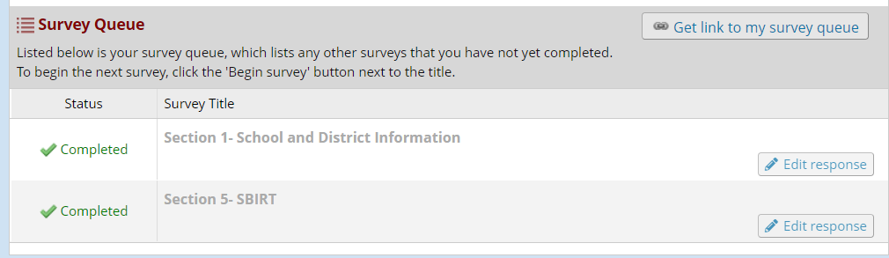
- Then scroll down to the bottom of the page until you get to Question 11. Change your selection from “Only SBIRT data” to “Both BMI and SBIRT data and nothing else.”
- Then click Submit. That should open the BMI section of the report. Enter your BMI data, then click Submit.

